**DSC 640 Data Visualization**

**Trisha Winquist 6/15/2024**

**Is traveling by Air a safe way to travel?**

Airline Travel has been around for many years and there is an underlying question about how safe it is to fly in the air.

If you are thinking about traveling with airlines and worrying about your safety, you have reached the right place.

This data visualization project used data from Airline safety with accidents and fatalities per year.

**Fatality Trend over Years for Airlines**

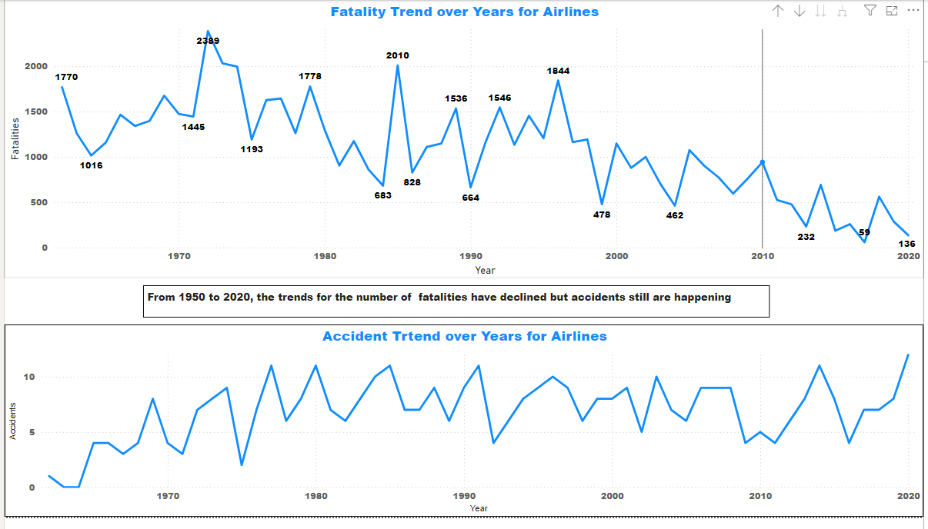

**I used these line charts to show the difference between the Fatalities over the years and the accidents that happen. Based on the line charts, the fatalities have been reduced over time, but the accidents show that they have stayed relatively the same. The change in fatalities over time was a 66 % decrease.**

**Airline VS Automobiles**

**Using the standard metric to measure the safety of airlines and automobiles, airlines show a lower fatality rate. The fatality rate for automobiles remains unchanged whereas the fatality rate for airlines have been on a decline.**

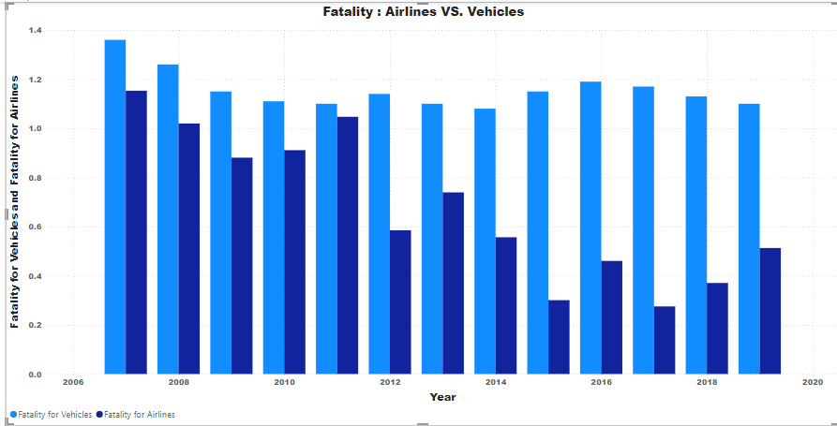

**Sales and Forecasting**

Fatalities in airlines are rare occasions, which happen due to unexpected events.

Despite the negativity surrounding airlines, the airline industry sees year-over-year increases in sales across all US airline companies

The pie chart indicates all the airlines and fatalities by airlines. Malaysia Airlines had more fatalities than all of the airlines.

There are a lot of Countries in this pie chart, but let's look at the highest rank. Malaysian Airlines has seen the highest number of fatalities between 2000-2014. This chart should immediately tell us that Malaysia Airlines was an outlier, which unfortunately contributed significantly to the number of fatalities. There was a tragic disappearance of a Malaysian airplane in 2014, which remains a mystery to this day. Without this tragic incident, the spike in 2014 would be far lower. This data shows us that the spike in fatalities does occur randomly throughout the years, but they are extremely rare.

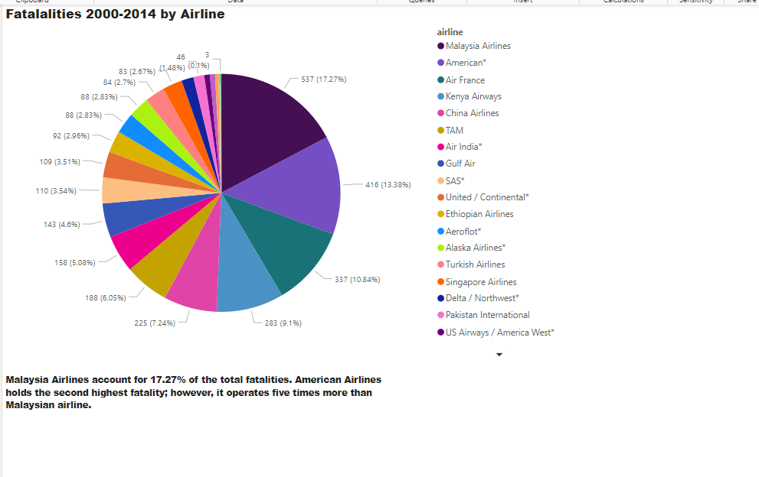

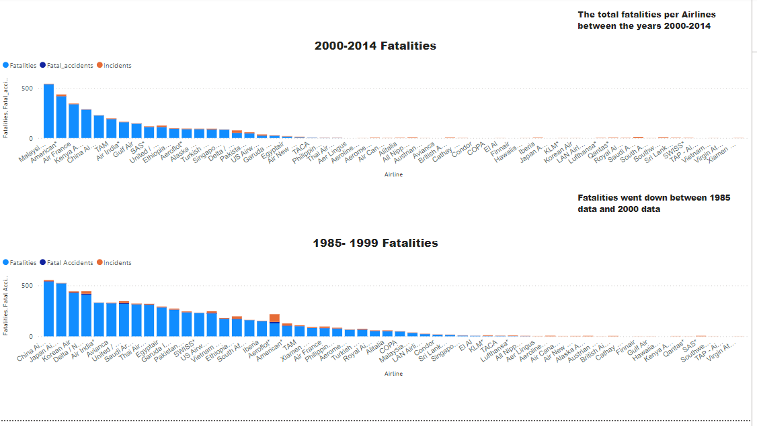

**This bar graph indicates that the fatalities on the airlines went down from (1985-1999) data to (2000-2014) data. And the number of instances was also lower.**

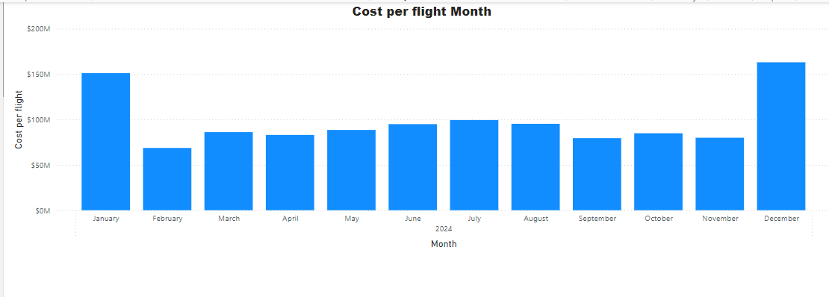

If you are looking to save some money, then this chart indicates some upticks in the sales per month. Dec and January indicate that the sales seem to be the highest which could be due to Holiday travel.